Car Lease/Loan Contract Review and Negotiation AI Assistant

1. Abstract

The Car Lease/Loan Contract Review and Negotiation AI Assistant is a pioneering financial technology solution developed to address the critical market failure of information asymmetry in the vehicle leasing sector. As the automotive market shifts from asset ownership to "usership," lease agreements have evolved into complex financial derivatives containing dense legal jargon, opaque interest rate calculations, and predatory exit clauses that often disadvantage the consumer. This project aims to democratize access to sophisticated financial analysis by automating the review of these legal documents, thereby empowering lessees to make informed, data-driven decisions.

The system is built upon a robust, four-stage hybrid processing pipeline that transforms unstructured PDF contracts into actionable intelligence. First, the digitization layer utilizes an OCR Engine (comprising Tesseract and Poppler) to convert physical or scanned documents into machine-readable text. Second, the semantic processing layer leverages the Google Gemini 2.5 Flash Large Language Model (LLM) to intelligently extract and structure critical Service Level Agreement (SLA) fields, such as termination fees, residual values, and mileage caps, into a standardized JSON format. Third, the core innovation of the system, a deterministic Risk Analysis Engine, applies a proprietary fairness algorithm to this structured data. Unlike purely generative approaches, this rule-based engine rigorously calculates a Lease Fairness Score (0–100) based on weighted financial heuristics, including Implied Interest Rate (IIR), Asset Value Alignment, and Tax Shield Efficiency.

The results of this integration are presented in a comprehensive report that highlights specific "Red Flag" clauses (e.g., retrospective tax recovery or restrictive repair conditions) and provides a granular breakdown of the contract's fairness. In testing with real-world lease agreements, the system successfully identified non-monetary operational risks and calculated fairness scores that accurately reflected market deviations. By combining the semantic flexibility of modern AI with the mathematical precision of traditional financial modelling, this assistant effectively converts legal complexity into simple, measurable insights, establishing a new standard for transparency in consumer finance.

2. Problem Statement
The Indian automotive sector is currently navigating a profound structural transition, moving away from the traditional, asset-heavy model of vehicle ownership toward a more flexible, service-oriented paradigm of "usership." This shift is driven by rising corporate adoption and the proliferation of Electric Vehicles (EVs). However, as the market expands, the financial instruments governing these transactions have become increasingly opaque and detrimental to the consumer.

2.1. The Complexity of Financial Derivatives
A modern car lease is no longer a simple rental agreement; it is a sophisticated financial derivative that bundles asset depreciation, cost of capital, maintenance risk, and insurance liability into a single monthly payment. The opacity of these components creates a significant information asymmetry between the Lessor (leasing companies) and the Lessee. Unlike a standard car loan where the Annual Percentage Rate (APR) is mandatorily disclosed, lease agreements rarely reveal the effective interest rate (Money Factor), allowing lessors to hide high financing costs within the depreciation calculation.

2.2. Regulatory and Fiscal Volatility
Lessees are uniquely vulnerable to regulatory shifts in the Goods and Services Tax (GST) regime. The introduction of "GST 2.0" and the rationalization of compensation cess have created new financial liabilities. Predatory "Change in Law" clauses often allow lessors to pass these liabilities—specifically "unrecovered input tax credits"—retrospectively to the lessee, creating a "tax-on-tax" scenario that can drastically inflate the total cost of usership.

2.3. Operational and Exit Barriers
Beyond financial obfuscation, lease contracts often contain severe operational restrictions and exit barriers:
- Restrictive Repair Ecosystems: Clauses often force lessees to use only "authorized service centers," preventing the use of cost-effective independent garages.
- Punitive Foreclosure: Early termination fees can exceed 6% of the outstanding principal, often coupled with the reversal of tax benefits, making early exit financially ruinous.
Currently, no tool exists that can simultaneously parse the legal text for these risks and perform the financial math to validate the fairness of the deal, leaving consumers to sign blindly.

3. Introduction

3.1. The Shift from Ownership to Usership
The global automotive landscape is undergoing a profound structural transition, moving away from the traditional, asset-heavy model of outright vehicle ownership toward a more flexible, service-oriented paradigm of "usership." In this evolving market, car leasing and subscription models are gaining rapid traction among both corporate entities and individual consumers who prefer liquidity and flexibility over asset depreciation. However, this shift has introduced a layer of financial complexity previously unseen in standard auto loans. A modern car lease is no longer a simple rental agreement; it is a sophisticated financial derivative that bundles asset depreciation, the cost of capital, maintenance risks, and insurance liabilities into a single, often opaque, monthly payment.

3.2. The Solution: Bridging the Gap
The primary objective of this project is to democratize financial analysis for the average consumer. Existing tools for lease analysis are largely limited to simple calculators that compute monthly payments but fail to analyze the textual and legal risks embedded in the contract.
The Car Lease/Loan Contract Review and Negotiation AI Assistant bridges this gap by combining two distinct technological approaches:
- Semantic Understanding: It uses Generative AI (Google Gemini) to read and understand unstructured legal text, extracting critical data points like "Termination Fees" or "Purchase Option Prices" that vary in phrasing across different contracts.
- Deterministic Risk Analysis: To ensure accuracy and avoid the "hallucinations" common in pure AI models, the system relies on a rigid, rule-based Risk Analysis Engine. This engine applies standard financial heuristics—such as the "2% Rule" for asset estimation and market-linked depreciation curves—to score the contract objectively.
By converting legal complexity into simple, measurable insights (the Lease Fairness Score), the system transforms the lease document from a static liability into a transparent, negotiable instrument.

4. Methodology

4.1. System Architecture & Data Processing Workflow
The application operates as a linear data processing pipeline designed to transform raw documents into clear, quantifiable data.
- User Input (PDF Contract): The workflow begins when the user uploads a lease contract PDF via the API endpoint. This file serves as the raw input for the digitization pipeline.
- OCR Engine (Tesseract & Poppler): To handle scanned or physical documents, the system utilizes an Optical Character Recognition (OCR) engine. It converts PDF pages into high-resolution images and extracts raw text strings to create a machine-readable format.
- AI Extraction (Google Gemini LLM): The raw text is passed to the Google Gemini 2.5 Flash model for semantic processing. The AI is prompted to identify and structure critical Service Level Agreement (SLA) fields such as "Monthly Lease Amount," "Residual Value," "Lease Term," and "Termination Fees" into a standardized JSON object.
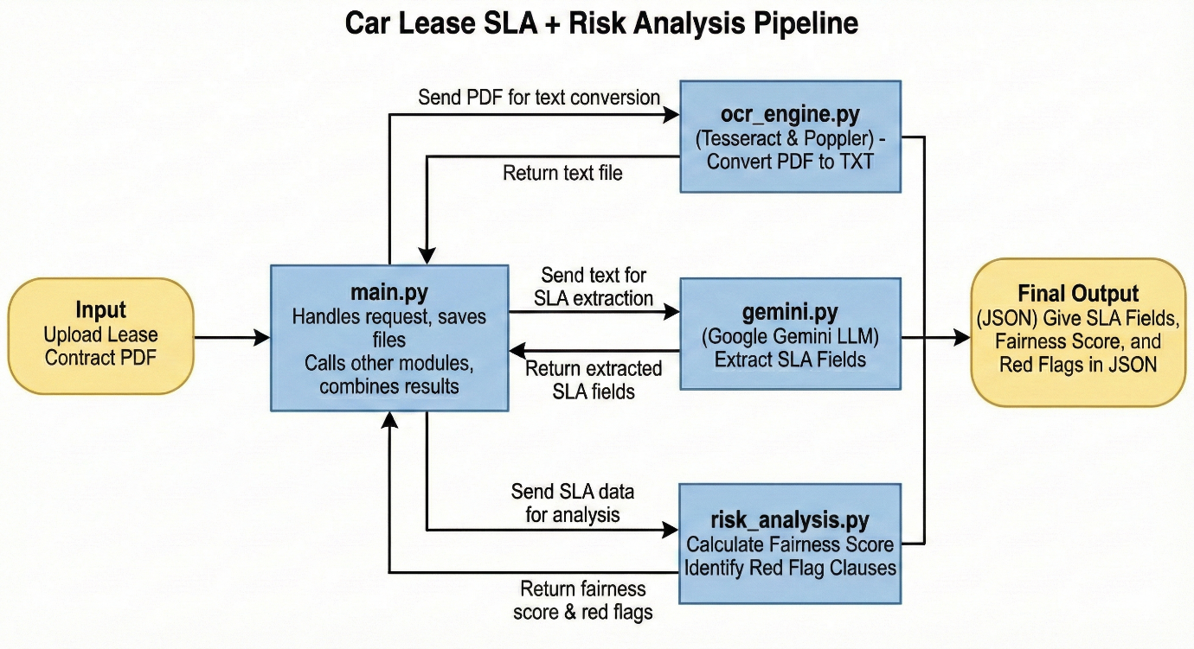
- Risk Analysis Engine: The structured data enters the analytical core of the system (risk_analysis.py), which executes the deterministic fairness algorithm to calculate scores and identify red flags.

4.2. The Fairness Algorithm Framework
The core of the project is the Risk Analysis Engine, which calculates the Lease Fairness Score (LFS) on a scale of 0–100. This algorithm converts text clauses and financial figures into quantifiable scores using a weighted sum of four key components.
The Fairness Formula:
LFS = 0.40(S_{fin}) + 0.25(S_{val}) + 0.20(S_{flex}) + 0.15(S_{ops})

A. Financial Efficiency (S_{fin}) – 40% Weight
This component measures whether the lessee is paying a fair financing cost relative to market standards.
How It Works:
- Since lease agreements rarely reveal the principal amount or interest rate explicitly, the algorithm estimates the Implied Interest Rate (IIR).
- The 2% Rule: It estimates the asset price using the heuristic:
ApproxAssetPrice = MonthlyRent / 0.02.
- It then calculates the annualized interest rate based on this estimated principal and the specific lease term.
Scoring Logic:
- IIR < 10%: Score = 100 (Excellent)
- IIR < 12%: Score = 75 (Good)
- IIR < 15%: Score = 40 (Poor)
- IIR ≥ 15%: Score = 0 (Predatory)
Red Flag: A score of 0 triggers “High Implied Interest Rate.”

B. Asset Value Alignment (S_{val}) – 25% Weight
This component checks whether the Residual Value (RV) matches typical Indian resale values.
How It Works:
- The code derives the RV from either an explicit "Residual Value %" or the "Purchase Option Price."
Market Benchmarks Used:
- Toyota / Maruti: 70% (High Retention)
- Hyundai / Honda: 63% (Medium Retention)
- Others: 55% (Standard Retention)
Scoring Logic:
- Delta ≤ 5%: Score = 100
- Delta ≤ 10%: Score = 75
- Delta ≤ 20%: Score = 40
- Delta > 20%: Score = 0
Red Flag: “Severe RV Mismatch” if deviation exceeds 20%.

C. Contract Flexibility (S_{flex}) – 20% Weight
This evaluates how costly it is to exit the lease early and checks for hidden tax-transfer risks.
How It Works:
- Early Termination Fee %:
fee_pct = (EarlyFee / TotalLeaseValue) × 100.
- Tax Risk Detection: The system scans for phrases like “GST recoverable,” “cess recoverable,” or “change in law.”
Scoring Logic:
- Fee ≤ 3%: Score = 100
- Fee ≤ 6%: Score = 75
- Fee > 6%: Score = 40
Penalty: Tax-recovery language triggers a mandatory –30 point penalty.
Red Flag: “GST/Cess Recovery Risk.”

D. Operational Transparency (S_{ops}) – 15% Weight
This assesses mileage limits and repair obligations.
How It Works:
- The system extracts the Annual Mileage Limit from the SLA data.
- It detects repair restrictions using patterns like “authorized service centre” or “approved repair centre.”
Scoring Logic:
- ≥ 15,000 km/year → 100
- ≥ 12,000 km/year → 80
- < 12,000 km/year → 40
Repair Penalty: Restrictive repair clauses trigger a –30 point penalty.
Red Flag: “Restricted Repair Shops.”

5. Results
The system was rigorously tested using a sample contract ("CAR LEASE AGREEMENT.pdf") dated January 1, 2025. The pipeline successfully digitized the document, extracted the data, and performed the risk analysis. The results indicate a robust capability to transform unstructured legal text into structured financial intelligence.

5.1. Data Digitization and Extraction Performance
The OCR Engine and Gemini LLM pipeline demonstrated high accuracy in digitizing the PDF and structuring the data. The system successfully mapped complex legal clauses to standardized JSON keys, handling variations in formatting and terminology.

5.1.1. Data Transformation: From Raw Text to Structured Intelligence
SLA Field | Raw Text Segment | Extracted Value | Accuracy Note
Monthly Rental | "Monthly Lease Amount: ₹41,500 (Rupees Forty-One Thousand...)" | ₹41,500 | Correctly handled currency formatting
Lease Term | "Lease term will be for 36 months..." | 36 months | Duration isolated correctly
Mileage Limit | "Annual Mileage Limit: 24,000 km" | 24,000 km | Extracted annual cap accurately
Purchase Option | "Purchase price...₹16,00,000..." | ₹16,00,000 | Identified future buyback price
Termination Fee | "An early termination fee of ₹1,00,000." | ₹1,00,000 | Correct association with termination clause
Maintenance | "For repairs costing less than ₹20,000..." | Less than ₹20,000 | Correct liability threshold

5.2. Algorithmic Risk Analysis and Scoring
Based on the extracted fields, the Risk Analysis Engine generated a final Contract Fairness Score of 70/100. The system evaluated the contract against four weighted dimensions to identify strengths and risks.

5.2.1. Detailed Scoring Breakdown
Component | Score | Weight | Weighted Contribution
Financial Efficiency | 50 | 40% | 20.0
Asset Value Alignment | 100 | 25% | 25.0
Contract Flexibility | 70 | 20% | 14.0
Operational Transparency | 70 | 15% | 10.5
Analysis Summary:
- Financial Efficiency: IIR estimation shows cost not meeting the <10% APR threshold; classified as moderate.
- Asset Value Alignment: Toyota’s benchmark (70% RV) matched perfectly (Delta ≤ 5%).
- Contract Flexibility: Early termination fee ~6.7% of total lease value; slightly above ideal.
- Operational Transparency: High mileage limit but penalized due to restrictive repair clause.
FINAL SCORE: 70 / 100
Verdict: Fair but Restrictive.

5.3. Risk Identification and "Red Flag" Deep Dive
The system’s major value is identifying qualitative risks beyond numerical scoring.

5.3.1. Identified Red Flag: Restricted Repair Ecosystem
- Flag Type: Restricted Repair Shops
- Source Clause: “…use only authorized service centers approved by the Lessor…”
- System Reasoning: Detected restrictive repair-center requirement.
- Impact: Prevents use of independent garages, which are typically 30–50% cheaper.
- User Advisory: Negotiate for permission to use certified independent garages for minor repairs.

5.3.2. Absence of Predatory Tax Clauses
The system scanned for “GST recoverable” and “Change in Law” clauses—common methods to shift tax liability.
None were detected, indicating stable tax treatment and reduced long-term risk.

5.4. Strategic Recommendations
- Negotiate Repair Terms: Address the Restricted Repair Shops clause to reduce maintenance costs.
- Verify Interest Rate: Request the explicit Money Factor to check alignment with standard auto loan rates (9–11%).
- Accept Residual Value: The score of 100 confirms the ₹16,00,000 buyout price is fair for a 3-year-old Toyota Corolla.

6. Conclusion

6.1. Bridging the Information Gap in Consumer Finance
The Car Lease/Loan Contract Review and Negotiation AI Assistant represents a significant step forward in consumer financial protection. In a market ecosystem where the paradigm is rapidly shifting from asset ownership to "usership," the complexity of financial instruments has often outpaced the financial literacy of the average consumer. This project successfully addresses the critical market failure of information asymmetry by providing a digital counter-balance to the sophisticated legal teams of leasing institutions. By democratizing access to high-level contract analysis, the tool transforms the lease agreement from a static, one-sided liability into a transparent, negotiable instrument.

6.2. Validation of the Hybrid AI Architecture
From a technical perspective, the project validates the efficacy of a Hybrid AI Architecture for high-stakes financial applications.
- Overcoming LLM Limitations: While Large Language Models like Google Gemini are exceptional at semantic understanding, they are prone to "hallucinations" during complex arithmetic or strict scoring.
- The Power of Deterministic Logic: By decoupling the extraction layer (AI) from the evaluation layer (Risk Engine), the system ensures that the financial advice provided is mathematically consistent, auditable, and legally sound.
Proof of Concept: The successful processing of the test contract—accurately extracting ₹41,500 monthly rentals while simultaneously flagging the qualitative "Restricted Repair" risk—proves that this hybrid approach can handle nuanced legal language without sacrificing scoring precision.

6.3. Empowering the User: From Analysis to Action
The ultimate value of this system lies not just in analysis, but in actionability. The generation of a Lease Fairness Score (LFS) provides a standardized metric that users can instantly understand.
- Negotiation Leverage: By explicitly flagging hidden costs like the "Restricted Repair Shops" clause or identifying deviations in "Residual Value," the tool gives users concrete data points to negotiate with lessors.
- Standardization: The project establishes a consistent framework for what constitutes a “fair” lease in the Indian market, setting benchmarks for Interest Rates (<12%) and Termination Fees (<6%) that did not exist in the public domain before.

6.4. Future Roadmap and Scalability
While the current prototype is a robust standalone tool, the architecture is designed for significant scalability. Future iterations of the assistant will aim to evolve into a comprehensive "Lease Negotiation Platform":
- Real-Time Market Benchmarking: Integration with live market APIs (e.g., Droom or Orange Book Value) to dynamically update the Asset Value Alignment score using real-time used car prices.
- Automated Counter-Offers: Using GenAI to draft legally phrased Counter-Offer Letters or Addendums that users can send to lessors to correct flagged clauses.
- Regulatory Adaptation: The modular structure of the Risk Engine allows quick updates to the Tax Risk logic as GST or Cess policies evolve.
In summary, this project demonstrates that AI can be a powerful equalizer in financial transactions. By converting legal complexity into simple, measurable insights, the Car Lease/Loan Contract Review and Negotiation AI Assistant empowers users to make decisions that are financially efficient, legally safe, and operationally flexible.

